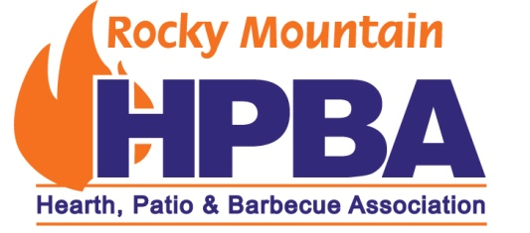
2019 Sponsorship Form
Please partner with us as a 2019 sponsor! Get involved with our association and help us provide benefits to our members.
This sponsorship will include the following:
- Acknowledgement in all RMHPBA newsletters
- Logo displayed on RMHPBA’s website, www.rmhpba.org, with a direct link to your company’s website
- Social media event promotional posts
- Logo displayed at all RMHPBA functions, including the annual event and educational workshops
- Our annual event will be 5:30 p.m. – 9:00 p.m., Friday, April 26, at Punch Bowl Social in Denver, Colorado. See what Punch Bowl Social has to offer at www.punchbowlsocial.com/location/stapleton. All sponsors in attendance at the event will receive a special welcome and acknowledgement.
Premier Sponsor $2500.00
Includes items listed above, and 5 tickets to the event, 6’ table for displaying
Platinum Sponsor $1000.00
Includes items listed above, and 3 tickets to the event, 6’ table for displaying
Gold Sponsor $500.00
Includes items listed above, and 2 tickets to the event
Silver Sponsor $300.00
Includes items listed above, and 1 ticket to the event
Please select what level of sponsorship:
Premier*________________
Platinum* _______________
Gold____________________
Silver___________________
*Please let me know if you will need a table for displaying
Any other donation, such as something to give away, would be greatly appreciated.
If you need an invoice for a donation or have any questions, please contact Larry Grogan at 480-772-2169 or rmhpba@outlook.com.
Please pay online at www.rmhpba.org or send payment to:
RMHPBA
c/o Larry Grogan
1130 Riparian Dr.
Columbia Falls, MT 59912
Thank you for your support,
The RMPBA Board of Directors

