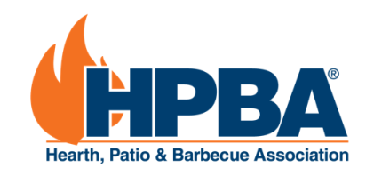

National Fireplace Month 2020 Promotional Campaign:
“Home is Where the Hearth Is”

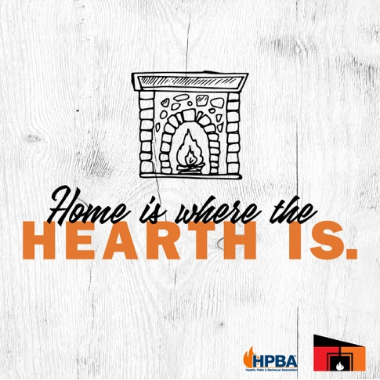
This fireplace season, it’s likely consumers will be spending more time at home than ever before. With uncertainty swirling outside our homes, the hearth is truly the center of warmth, comfort and relaxation in our lives.

This year for #NationalFireplaceMonth, HPBA is conducting a national media relations and social media campaign called “Home is Where the Hearth Is” encouraging people to make the most of their fireplaces this season.

“Home is Where the Hearth Is” will inform consumers on how to prep their fireplaces for the season; encourage they work with specialty retailers and NFI-certified specialists; offer tips on making the most of the fireplace during these uncertain times; provide a playlist of the best songs to enjoy fireside; and, even ask people to share “awkward family photos” together by the fire.

We hope you can take part. We encourage you to share our press release and share these posts throughout October on your channels. Or, follow our social media pages on Facebook and Instagram pages and share. Remember, always use the hashtag #NationalFireplaceMonth.

Social media posts and graphics:
Post 1:  It's #NationalFireplaceMonth! As the focal point of so many of our homes, the fireplace is also where our best memories are made. What’s your favorite fireside memory? 🔥 | 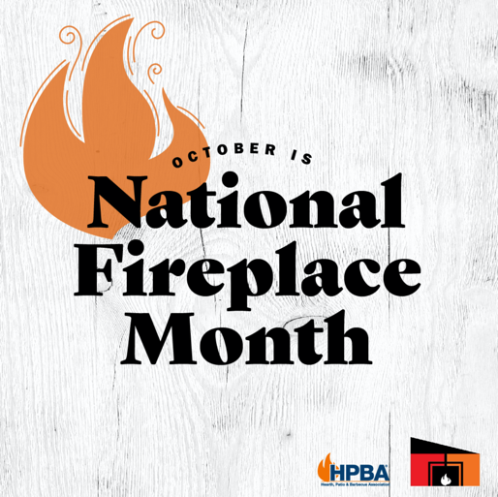  https://drive.google.com/file/d/1YK2xDluP5TmPH3s5Z-hYBbgFep-z2hKN/view?usp=sharing
Post 2:  The shorter days of fall are no problem when you have a source of light and warmth inside! 🍂🔥 We’d be happy to help you cozy up your home in preparation for winter with the perfect fireplace. #NationalFireplaceMonth | 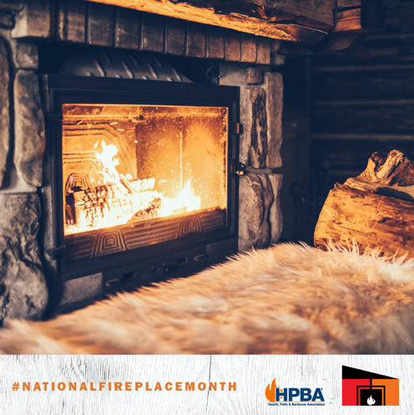  https://drive.google.com/file/d/1bVQFeNdgCasjp0pnhlJFuLgYry4DPYLA/view?usp=sharing
Post 3:  Invite hygge into your home this winter with a homey hearth and fireplace! 🔥 We can help you create the perfect ensemble for your space. #NationalFireplaceMonth | 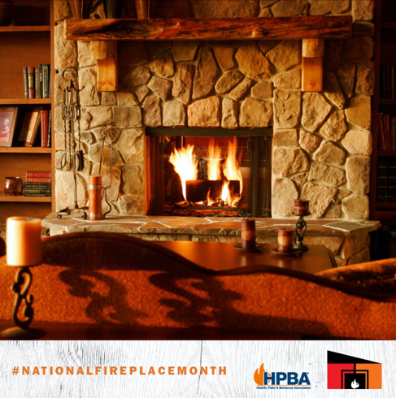  https://drive.google.com/file/d/1mfFA3vjNreyQE9xcuU-mu-A--nJBOASS/view?usp=sharing
Post 4:  The fireplace makes a house a home, but it’s the design and comfort of the hearth that makes it so special. Home Is Where the Hearth Is, after all! Share a photo of your home’s hearth below. 👇 #NationalFireplaceMonth | https://drive.google.com/file/d/1u-HBoQn6WqHtAZFe-erKKGaeI11QjrFP/view?usp=sharing
Post 5:  The world may be swirling outside your front door, but peace and comfort can be found inside, especially with the soothing flames of a fireplace. 🔥 From bathrooms to kitchens, home offices and more, we can help you reimagine your fireside spaces. Where would you put your next fireplace? #NationalFireplaceMonth | 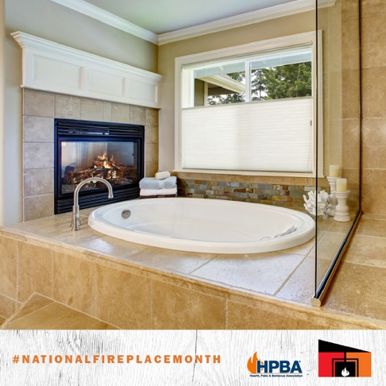  https://drive.google.com/file/d/1m6RKfWDGzOQ4jq3yfxYygbkcmZEUHWAQ/view?usp=sharing
Post 6:  Fireplace Safety Tip: Check your chimney each #NationalFireplaceMonth to ensure the structure is sound. Any cracks? Bricks coming loose? Loose mortar? We can also connect you with an inspector to get a thorough, professional inspection. | 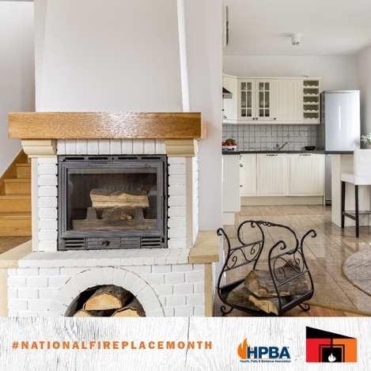  https://drive.google.com/file/d/1q4YV7VrcW-FgrCzz1F-oGDlw-WokZwYJ/view?usp=sharing
Post 7:  Chances are we’ll spend more time by our fireside this winter than ever before. 🔥❄️ Remote working, distant learning, binging TV, reading books and celebrating holidays. How do you plan to spend your time by the fire? #NationalFireplaceMonth | 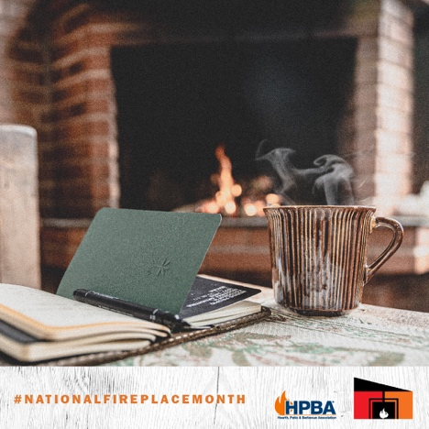  https://drive.google.com/file/d/1SDCnoREpFOkZtA7Yh6kOPzMG87Vs9fch/view?usp=sharing
Post 8:  When the world outside gets overwhelming, retreat to your peaceful fireside space and press play on this playlist. 🔥🎶 It’s specifically designed to bring good vibes when enjoyed by the fire: https://open.spotify.com/playlist/4VJ6n70WkB7b7kQ9TPrWSk?si=f_7z1uTYSCmGeMT_M3WPVw | 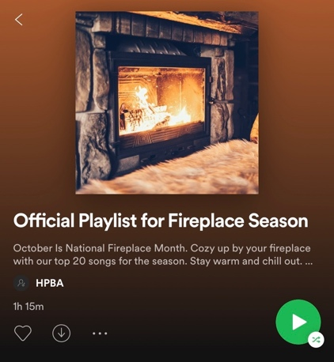  https://drive.google.com/file/d/1f101VjOE9-jvuKUO9SG7XEDLIwHKZrF3/view?usp=sharing
Post 9:  The hearth is the heart of our homes.❤️ It’s a center of safety in an ever-changing world. What do you love most about your fireplace? #NationalFireplaceMonth | 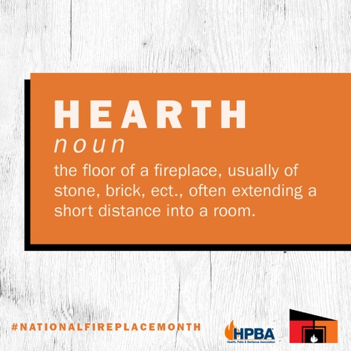  https://drive.google.com/file/d/1kHJ7lTovtAb4gYC5Vlhk7XK6ap_q5Sr1/view?usp=sharing
Post 10:  Make your bedroom even more relaxing with the warm, subtle flames of fireplace. 🔥💤 Let's design your dream bedroom hearth together! | 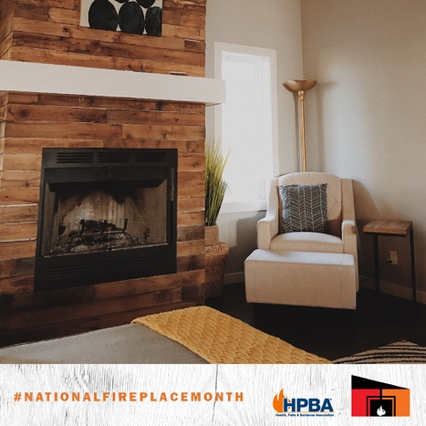  https://drive.google.com/file/d/1B1dG_NMcIaOynEgxezW-4zvMUOSEyH8i/view?usp=sharing

Mark your Calendar! HPBA Hearth will be running two Facebook comment contest giveaways throughout #NationalFireplaceMonth. Feel free to share using the copy below to engage your audience in the activities.

Oct. 1 | Check out this post from @HPBAHearth in celebration of #NationalFireplaceMonth! You could win a $25 Amazon gift card for participating.
Oct. 19 | Pull out your awkward family photos or run to the fireplace and take one now. They could win you a $25 Amazon gift card over on the @HPBAHearth page!

