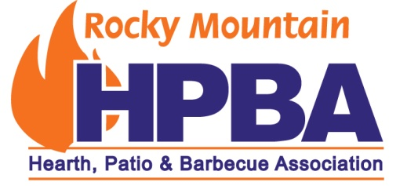
RMHPBA Annual Meeting Survey – Please take a few minutes and fill out the attached survey, and send it back to: Email to: rmhpba@outlook.com
Mail to: RMHPBA 1130 Riparian Dr. Columbia Falls, MT 59912
Fax to: 406-897-2310
Please respond by July 25, 2018!
- Did you attend the RMHPBA annual event in Denver on April 20, 2018 at Punch Bowl Social.

If you answered yes, go to question #2. If you answered no skip to question #6.
- How important were each of the following factors in your decision to attend RMHPBA’s annual meeting?
- Being able to talk to sponsors Yes ___ No ___
- Being able to network with other dealers Yes ___ No ___
- Location Yes ___ No ___
- Reception Yes ___ No ___
- NFI Reviews and Exams Yes ___ No ___
- Other ( What:______________________________) Yes ___ No ___
Please mark all that apply.
- How satisfied were you with the event overall?
- Very Satisfied __________________________
- Somewhat Satisfied __________________________
- Neutral __________________________
- Somewhat Dissatisfied________________________
- Very Dissatisfied __________________________

- The factors that you thought were important to attend the event; did they meet your expectations?
- Being able to talk to sponsors Yes ___ No ___
- Being able to network with other dealers Yes ___ No ___
- Location Yes ___ No ___
- Reception Yes ___ No ___
- NFI Reviews and Exams Yes ___ No ___
- Other Yes ___ No ___
Page 2
- Was the duration of the event:
- Much too long ______________
- A little long ______________
- Just Right ______________
- A little short ______________
- Much too short ______________

- Non-Attendees:
- Too Busy at work ___
- Going to EXPO ___
- Not interested in meeting sponsors ___
- Not interested in NFI classes ___
- Other commitments ___
- Attending too many other distributor meetings ___
- Other _________________________________________

- What’s the one thing that you wish the RMHPBA annual meeting would offer? If you did not attend the meeting, what things which if offered would cause you to attend?
____________________________________________________________________________
____________________________________________________________________________
____________________________________________________________________________
- Your RMHPBA Board is considering changing the Annual Meeting to make it more relevant to the members. The following are some ideas on how to the meeting could change. Please rate the following ideas as Least Appealing (1) to Most Appealing (5).
- Have training available other than just NFI classes ___
- Hold meeting every two years ___
- Continue meetings as we have the last 3 years ___
- Hold small meeting in each state other than the one big meeting ___
- Other_______________________________________________________________

- Other Comments:

Page 3
Help us understand who is responding to our survey by answering the following questions!
- Your age
- Under 30 ___
- 30-40 ___
- 41-50 ___
- 51-64 ___
- 65+ ___

- number of years you have worked in the hearth industry
- 0-5 ___
- 6-10 ___
- 11-19 ___
- 20+ ___

- What is your primary responsibility?
  - Retailer ___
  - Service Person ___
  - Business Owner ___
  - Distributor ___
  - Manufacturer Rep. ___
  - Salesman ___
Thanks so much for participating in this survey! You are helping to make your organization better!

